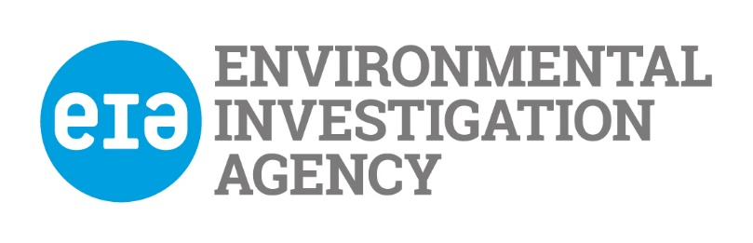

Guidelines for Applicants

Please read these notes carefully before completing the application form. Your job pack contains a job description, job specification, application form, equal opportunity monitoring form

Job Description

This describes the objectives and duties of the job for which you are applying. You should check that you feel able to undertake the duties of the job before applying. Please give examples of how your achievements are relevant to this job description when completing Part 5.

Person Specification

This describes the skills, experience, knowledge and other factors we shall be looking for when selecting applicants.

Please read this carefully and address how you fulfil each point when answering Section 5 on the application form.

It is very important that you fill this in accurately and concisely, giving evidence of skills and experience where possible.

General Information

EIA only accepts applications by email.

If you are short-listed for interview we will reimburse the cost of your London travel at standard class public transport rates on production of receipts.

Application for employment with The Environmental Investigation Agency (UK) Ltd

Please read the guidance notes before you fill in this application form

Office use
Date received

Post Details
Post applied for: | Post reference no:

Part 1. Personal Details
Title: | First name:
Other: | Last name:
Address: | Home phone number:
 | Work phone number:
 | Mobile phone number:
Postcode: | E-mail address:
If you are currently working, how much notice would you have to give your employer?

Part 2. Work History

Please tell us about your work history including any part time or voluntary work. Please start with your most recent work:
.
Name & Address  of Employer | Job Title and Main Duties  (state if full/part time or voluntary) | From | To | Reason for leaving
 | .

Please give details of your main duties and achievements in your present or most recent job.

Part 3. Education and Qualifications (please use extra sheets if you need to)
Please list your educational history and qualifications, starting with the most recent

Dates | Qualification | Where this was gained  e.g. secondary school/college/university | Grade

Part 4. Other training (e.g. membership of professional bodies, training courses etc.)

Course/Qualification title | Date | Where this was gained

Part 5. Experience (Please use extra sheets if you need to)
Please explain how your experience and skills suit the post by addressing all the points in the Person Specification.
Essential
Knowledge
- Educated to degree level or other relevant professional training.
- Comprehensive knowledge of intelligence processes, techniques and skills.
- Knowledge of information governance requirements including legislation (e.g. Data Protection Act 1998), protocols and procedures (e.g. risk management).
Experience

- Minimum of two years’ experience within a professional intelligence discipline.
Proven experience of the following;
- Open source research
- HUMINT
- Geo-political analysis
- Criminal analysis
- Intelligence liaison
- Experience of bulk and discrete information management.
- All source analysis

- Experience of building and maintaining effective working relationships with external contacts.

Skills

- Ability to identify emerging trends, patterns, risks and opportunities related to suspected illegal activities, commodity flows and facilitating factors, using a range of techniques and tools.
- Ability to travel and support colleagues in challenging environments when required.
- Ability to produce concise intelligence outputs, including in written and diagrammatical forms.
- Close attention to detail.
- Skills in verbal and written communications, to a high degree of accuracy and fit for purpose to a variety of audiences, in ways that inform EIA’s work and communications
- Advocacy skills, including ability to clearly explain and justify rationale and recommendations
- Ability to work flexibly, with strong time-management skills
- Strong team-working skills, and ability to work independently.
- Ability to work in a non-discriminatory manner, with respect for diversity
- Fluent in English
- Legal right to work in UK
- Experienced user of Windows-based packages, and specialist analysis software tools.
- I2 Analyst notebook and iBase experience
Desirable

- Understanding or experience of working on environmental crime issues, especially illegal wildlife trade and illegal logging.
- Understanding of organised crime in South East Asia/China.
- Knowledge or experience of business and political culture in South East Asia/China.
- Experience using GIS mapping software.
- Working knowledge or fluency in appropriate language (Mandarin, Vietnamese, Thai, Laotian)
- Experience in independent travel overseas.
- Experience of working on law enforcement investigations.
- Accreditation as a financial investigator or equivalent training in financial investigations.

6. Existing Contacts within EIA

Please indicate if you know any existing employees, trustees or directors of EIA and if so how you know them, ‘know’ refers to any relationship, however remote.

7. References

If you have worked before or are currently working, one of your referees must be your present or last employer.

Referee 1  Name:  Position:  Address:  Phone number:  Email:  Type of reference | Referee 2  Name:  Position:  Address:  Phone number:  Email:  Type of reference
Can we contact your referees before your interview?

Referee 1 Referee 2

Part 8. Other Information

Do you need a permit to work in the United Kingdom? Yes/No

Have you ever been convicted, cautioned or bound over, or are you waiting to hear about a criminal conviction which is not considered to be spent? Yes/No

If yes please give details

Are there any reasonable adjustments that EIA should make if you are invited for interview? Yes /No

If yes please give details

Where did you hear about this job?

I declare that the information that I have given on this form is, to the best of my knowledge, true and complete. I understand that if it is subsequently discovered any statement is false or misleading, or that I have withheld relevant information, my application may be disqualified or, if I have already been appointed, I may be dismissed.

I hereby give my consent to EIA processing the data supplied on this application form for the purpose of recruitment and selection and to store this information for a period of 3 months

Your signature: | Date:

