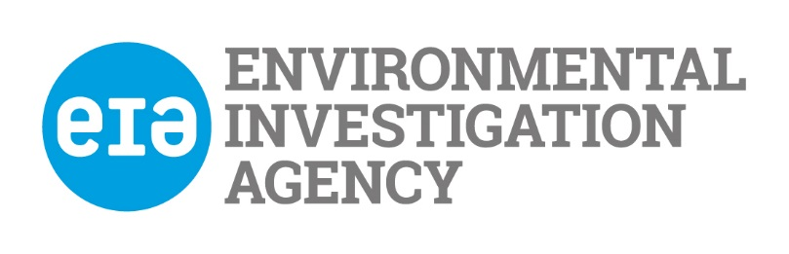

**Monitoring Questionnaire (Confidential)**

**Guidance Notes:**

EIA is an equal opportunities employer. We aim to provide equality of opportunity to all persons regardless of their religious belief; political opinion; sex; race; age; sexual orientation; or, whether they are married or are in a civil partnership; or, whether they are disabled; or whether they have undergone, are undergoing or intend to undergo gender reassignment.

We do not discriminate against our job applicants or employees on any of the grounds listed above. We aim to select the best person for the job and all recruitment decisions will be made objectively.

**This form will be used to monitor our recruitment process to ensure we are complying with our equal opportunities policy**.

You are not obliged to answer the questions on this form and you will not suffer any penalty if you choose not to do so.

However, we encourage you to answer the questions below. Your identity will be kept anonymous and your answers will be treated with the strictest confidence. We assure you that your answers will not be used by us to make any unlawful decisions affecting you, whether in a recruitment exercise or during the course of any employment with EIA.

**To protect your privacy, do not save and forward this form with your name, please save it with the job title you are applying for.**

**The form will be separated from the application form and it will carry a unique identification number and only our Monitoring Officer will be able to match this to your name.**

**Sex:**

**Please indicate your sex by ticking the appropriate box below:**

Male: 

Female: 

**Racial Group:**

**Please state your country of birth:**

My country of birth is: _________________________

**Please state your nationality:**

My nationality is: _________________________

**Please indicate which of the following applies to you:**

Chinese  Black Other 

Indian  Bangladeshi 

Pakistani  Black African 

Black Caribbean  White 

Mixed ethnic group (please state which): _________________________

Any other ethnic group (please state which): _________________________

**Disability:**

Under the *Disability Discrimination Act 1995* you are deemed to be a disabled person if you have cancer, multiple sclerosis or HIV infection.

Also, you are deemed to be a disabled person if you have a physical or mental impairment which has a substantial and long-term adverse effect on your ability to carry out normal day-to-day activities.

**Do you consider that you are a disabled person?**

Yes:  No: 

**If you answered “yes”, please indicate the nature of your impairment by ticking the appropriate box or boxes below:**

**Physical impairment**, such as difficulty using

your arms, or mobility issues requiring you to use

a wheelchair or crutches:

**Sensory impairment**, such as being blind or

having a serious visual impairment, or being deaf

or having a serious hearing impairment:

**Mental health condition**, such as depression

or schizophrenia:

**Learning disability or difficulty**, such as

Down’s Syndrome or dyslexia, or **Cognitive impairment**,

such as autistic spectrum disorder:

**Long-standing or progressive illness or health condition**,

such as cancer, HIV infection, diabetes, epilepsy or

chronic heart disease:

**Other** (please specify):

………………………………………………………………………

**Sexual Orientation:**

**Please indicate your sexual orientation by ticking the appropriate box below:**

My Sexual Orientation is:

I am straight: 

I am gay or lesbian: 

I am bisexual: 

**Marital Status / Civil Partnership Status:**

**Please indicate whether you are married or in a civil partnership by ticking the appropriate box below:**

Are you married or in a civil partnership?

Yes:  No: 

**Dependants / Caring Responsibilities**:

Do you have dependants, or caring responsibilities for family members or other persons?

Yes:  No: 

**If you answered “yes”, are your dependants or the people your look after?**

(Please tick the appropriate box or boxes):

A child or children: 

A disabled person or persons: 

An elderly person or persons: 

Other: 

If “Other”, please specify: ___________________________________

Thank you for your co-operation

This form will be deleted within 3 months of the closing date of the position you applied for.