Guidelines for Applicants

Please read these notes carefully before completing the application form. This contains a job description, person specification, application form, equal opportunity monitoring form.

EIA supports anonymous recruitment. This means that your personal identifying information will be removed prior to assessment and shortlisting, therefore avoiding bias from the hiring process.

We actively promote equality, diversity, and inclusion. In recruiting candidates, we seek candidates with the proven skills required, irrespective of race, gender, religion or belief, age, disability, or sexual orientation.

Job Description

This describes the objectives and duties of the job for which you are applying. You should check that you feel able to undertake the duties of the job before applying. Please give examples of how your achievements are relevant to this job description when completing Part 5.

Person Specification

This describes the skills, experience, knowledge and other factors we shall be looking for when selecting applicants.

Please read this carefully and address how you fulfil each point when answering Section 5 on the application form.

It is very important that you fill this in accurately and concisely, giving evidence of skills and experience where possible.

General Information

EIA only accepts applications by email.

If you are short-listed for interview we will reimburse the cost of your London travel at standard class public transport rates on production of receipts.

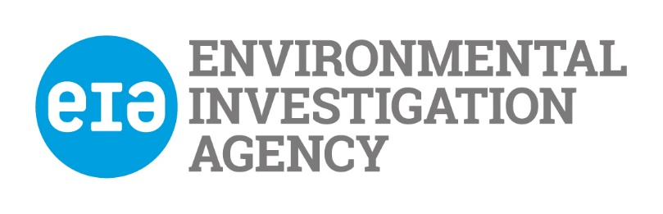

Application for employment with The Environmental Investigation Agency UK

Please read the guidance notes before you fill in this application form

Office use
Date received

Post Details
Post applied for: | Post reference no:

Part 1. Personal Details
Title: Mr | First name:
Other: | Last name:
Address: | Home phone number: -
 | Work phone number:
 | Mobile phone number:
Postcode: | E-mail address:
If you are currently working, how much notice would you have to give your employer?
One month

Part 2. Work History

Please tell us about your work history including any part time or voluntary work. Please start with your most recent work:
.
Name & Address  of Employer | Job Title and Main Duties  (state if full/part time or voluntary) | From | To | Reason for leaving

Please give details of your main duties and achievements in your present or most recent job.

Part 3. Education and Qualifications (please use extra sheets if you need to)
Please list your educational history and qualifications, starting with the most recent

Dates | Qualification | Where this was gained  e.g. secondary school/college/university |  | Grade

Part 4. Other training (e.g. membership of professional bodies, training courses etc.)

Course/Qualification title | Date | Where this was gained

Part 5. Experience (Please use extra sheets if you need to)
Please explain how your experience and skills suit the post by addressing ALL the points in the Person Specification. Please respond under each point
Essential
Knowledge
- Educated to degree level (or other relevant professional experience) or higher in a relevant subject
- Knowledge of UK and international marine environmental policy
- Knowledge of the UK and international marine environmental sector and key stakeholders operating in the space

Experience
- Experience of working for a campaigning organisation or equivalent
- Proven experience of researching, evaluating, interpreting and accurately representing information from a range of sources
- Proven policy and advocacy experience
- Experience of developing positive working relationships with external contacts.

Skills
- Strong advocacy skills, including the ability to clearly explain and justify rationale and recommendations
- Ability to analyse complex social, political, economic and environmental parameters in ways that inform EIA’s work and communications
- Ability to conduct detailed targeted research projects and tasks
- Strong interpersonal, communication and time-management skills
- Ability to understand and communicate highly technical and scientific issues
- Skills in verbal and written communications, to a high degree of accuracy and fit for purpose for a variety of audiences
- Ability to work flexibly, with strong time-management skills
- Fluent in English
- Legal right to work in the UK
- Experienced user of Windows-based packages, in particular Microsoft Office
- Strong organisational skills (information and data management, planning etc.)

Desirable

Knowledge
- Knowledge of UK, European and international policy institutions and processes
- Knowledge of global cetacean populations, including their conservation status, threats to their survival and global conservation action to address them
- Knowledge of IUU fishing and bycatch
- Knowledge of drivers, issues and solutions related to plastic pollution

Experience

- Experience working on advocacy related to cetaceans, IUU fishing and bycatch
- Experience working on UN and other international processes impact on cetaceans and IUU fishing, including International Whaling Commission (IWC)
- Experience of working in civil society coalitions

Skills
- Working knowledge or fluency in additional languages, in particular Japanese, Chinese or Spanish
- Ability to analyse large datasets using Excel
- Experience working with Microsoft Teams, Sharepoint and OneDrive for collaborative working
- Confidence working in a hybrid working environment

6. Existing Contacts within EIA

Please indicate if you know any existing employees, trustees or directors of EIA and if so how you know them, ‘know’ refers to any relationship, however remote.

7. References

If you have worked before or are currently working, one of your referees must be your present or last employer.

Referee 1  Name:  Position:  Address:  Phone number:  Email:  Type of reference | Referee 2  Name:  Position:  Address:  Phone number:  Email:  Type of reference
Can we contact your referees before your interview?

Referee 1 Referee 2

Part 8. Other Information

Do you need a permit to work in the United Kingdom?

Have you ever been convicted, cautioned or bound over, or are you waiting to hear about a criminal conviction which is not considered to be spent?

If yes please give details

Are there any reasonable adjustments that EIA should make if you are invited for interview?

If yes please give details

Where did you hear about this job?

I declare that the information that I have given on this form is, to the best of my knowledge, true and complete. I understand that if it is subsequently discovered any statement is false or misleading, or that I have withheld relevant information, my application may be disqualified or, if I have already been appointed, I may be dismissed.

I hereby give my consent to EIA processing the data supplied on this application form for the purpose of recruitment and selection and to store this information for a period of 3 months

Your signature: | Date:

