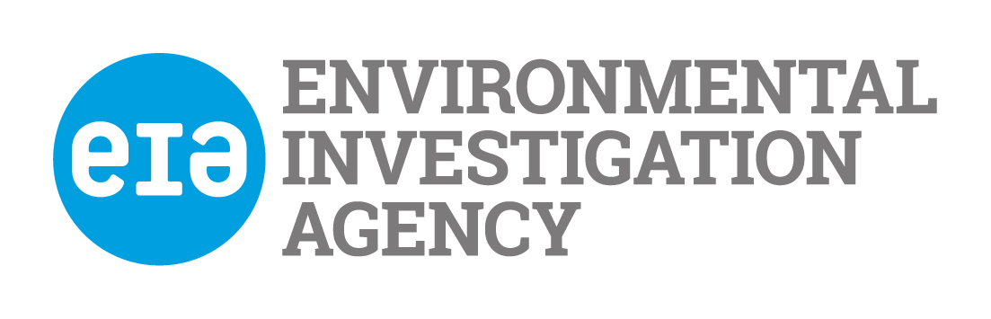

Guidelines for Applicants

Please read these notes carefully before completing the application form. Your job pack contains a job description, job specification, application form, equal opportunity monitoring form

Job Description

This describes the objectives and duties of the job for which you are applying. You should check that you feel able to undertake the duties of the job before applying. Please give examples of how your achievements are relevant to this job description when completing Part 5.

Person Specification

This describes the skills, experience, knowledge and other factors we shall be looking for when selecting applicants.

Please read this carefully and address how you fulfil each point when answering Section 5 on the application form.

It is very important that you fill this in accurately and concisely, giving evidence of skills and experience where possible.

General Information

EIA only accepts applications by email.

If you are short-listed for interview we will reimburse the cost of your London travel at standard class public transport rates on production of receipts.

Application for employment with The Environmental Investigation Agency UK

Please read the guidance notes before you fill in this application form

Office use
Date received

Post Details
Post applied for: | Post reference no:

Part 1. Personal Details
Title: | First name:
Other: | Last name:
Address: | Home phone number:
 | Work phone number:
 | Mobile phone number:
Postcode: | E-mail address:
If you are currently working, how much notice would you have to give your employer?

Part 2. Work History

Please tell us about your work history including any part time or voluntary work. Please start with your most recent work:
.
Name & Address  of Employer | Job Title and Main Duties  (state if full/part time or voluntary) | From | To | Reason for leaving
 | .

Please give details of your main duties and achievements in your present or most recent job.

Part 3. Education and Qualifications (please use extra sheets if you need to)
Please list your educational history and qualifications, starting with the most recent

Dates | Qualification | Where this was gained  e.g. secondary school/college/university | Grade

Part 4. Other training (e.g. membership of professional bodies, training courses etc.)

Course/Qualification title | Date | Where this was gained

Part 5. Experience (Please use extra sheets if you need to)
Please explain how your experience and skills suit the post by addressing all the points in the Person Specification.
- Educated to degree level in a relevant field such as communications; journalism; law / public policy or science with a focus on environmental, or conservation issues
- Experienced in a similar role in a campaigning organisation or media / communications field
- Proven research skills
- Proven written communication skills. Experience of summarising complex policy or technical research and analysis into appropriate messaging and communications materials for different target audiences
- Proven verbal communication and advocacy skills, including ability to justify rationale and recommendations
- Personable and persuasive approach with an ability to confidently engage contacts from various fields
- Ability to work independently with strong time-management and organisation skills, with attention to detail
- Experience of building and maintaining effective working relationships with diverse external contacts
- Works well in a team
- Legal right to work in the UK
- Prepared to travel outside the UK at short notice

Please address any of the desirable qualities as appropriate

6. Existing Contacts within EIA

Please indicate if you know any existing employees, trustees or directors of EIA and if so how you know them, ‘know’ refers to any relationship, however remote.

7. References

If you have worked before or are currently working, one of your referees must be your present or last employer.

Referee 1  Name:  Position:  Address:  Phone number:  Email:  Type of reference | Referee 2  Name:  Position:  Address:  Phone number:  Email:  Type of reference
Can we contact your referees before your interview?

Referee 1 Referee 2

Part 8. Other Information

Do you need a permit to work in the United Kingdom? Yes/No

Have you ever been convicted, cautioned or bound over, or are you waiting to hear about a criminal conviction which is not considered to be spent? Yes/No

If yes please give details

Are there any reasonable adjustments that EIA should make if you are invited for interview? Yes /No

If yes please give details

Where did you hear about this job?

I declare that the information that I have given on this form is, to the best of my knowledge, true and complete. I understand that if it is subsequently discovered any statement is false or misleading, or that I have withheld relevant information, my application may be disqualified or, if I have already been appointed, I may be dismissed.

I hereby give my consent to EIA processing the data supplied on this application form for the purpose of recruitment and selection and to store this information for a period of 3 months

Your signature: | Date:

